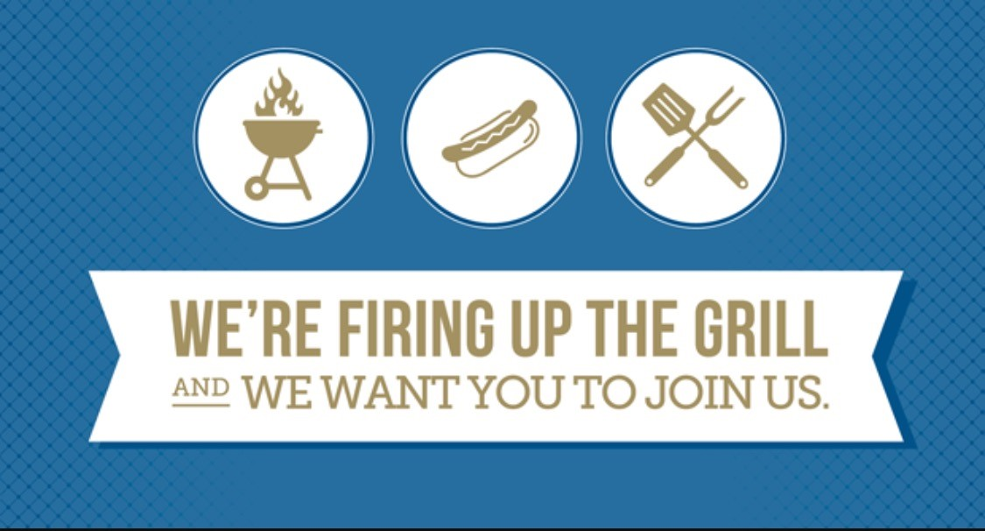

Indivisible South Suburban Chicago is Hosting a

Summer of Resistance Coalition Cookout

Sunday, August 13th 2pm until ?

Hickory Creek Junction 11916 W Lincoln Hwy Mokena, IL 60448

Come join us! Let's get to know each other better. Building community is the key to a lasting resistance organization. We are inviting many other area groups too.

We will provide the hot dogs and hamburgers. Please bring a dish to share and BYOB. Alcohol permitted.

Please bring your kids, family, friends, and neighbors. Bring sports equipment, lawn games or table games!

Please RSVP by Wednesday August 9th to Holly Fingerle [hollybee60443@gmail.com](mailto:hollybee60443@gmail.com) (708) 465-9396 or on FB event on Chicago Southland Summer of Resistance Page so we have enough meat for everyone to BBQ.